Tetsworth Parish Council
Clerk and RFO: Helen Croxford
Tel: 07501 306382
Email: clerk@tetsworthparishcouncil.co.uk

TETSWORTH PARISH COUNCILLORS

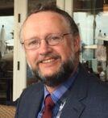 Paul Carr - Chair

Paul and his family have lived in Tetsworth for over 20 years. He has always been impressed by the many different aspects of life in our village and so, after a career in aviation and a brief previous spell on the Council from 2016-17, has re-joined the Parish Council following his retirement to help Tetsworth to fulfil its potential.

Email: paul.tetsworthpc@gmail.com

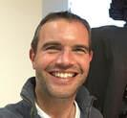 Seb Mossop – Vice Chair
Seb moved to Tetsworth 8 years ago from London. Looking for a peaceful environment to bring-up 2 young children, the village has provided exactly that. Our children attended the village school where they benefited from establishing great friendships and an excellent start to their education. We continue to enjoy everything the village has to offer and now, as part of the Parish Council, look forward to building on the strong relationships that exist across the village.

Email: seb.tetsworthpc@gmail.com

Susan Rufus

Susan has lived in Tetsworth for five years and really enjoys living in the Village. Having worked in Local Government as a Senior Environmental Health Inspector for 29 years, she has expertise in Food Safety, Health and Safety and Environmental Health matters. As a Parish Councillor she hopes to help the area to continue to be a great place to live and become more involved in Village life.

Email: susan.tetsworthpc@gmail.com

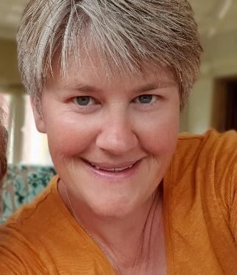 Karen Bennett

Karen has lived in Tetsworth since August 2017 and is a Co-opt Governor at Aston Rowant Church of England Primary School. Previously from London, She was part of the Metropolitan Police Special Constabulary and served at Shepherds Bush Police Station. As a Parish Councillor she continues to be passionate about helping the community in which she lives and get involved as much as possible.

Email: karen.tetsworthpc@gmail.com

Chris Thompson
Chris moved with his family to Tetsworth in 2010 having previously lived in Buckinghamshire, Norfolk and Surrey. An IT professional of over 20 years and now keen to help with issues affecting the village and local area.

Email: chris.tetsworthpc@gmail.com
​
All Councillors can be contacted by email or on the main parish telephone number above.

